Predicting Academic Success in Higher Education
  - Final Project

Submitted By:
Naina Gupta

Submitted on:
8-17-2023

Introduction
This report analyzes a higher education institution’s enrollment dataset for undergraduate degrees such as agronomy, design, education, nursing, journalism, management, social service, and technology. The goal is to build supervised machine learning models for accurately predicting a student’s academic success based on the given information about factors such as time of enrollment, student demographics, academic performance in the first and second semester, parents’ qualifications, and the economic condition at the time of course completion. By leveraging the data, we explore the predictive capacity of the given factors with respect to the odds of their academic dropout, provide actionable recommendations, and contribute to the reduction of dropouts in higher education.
The project involves exploring the dataset using Jupyter Notebook. We will conduct exploratory analysis, calculate summary statistics, and create informative graphs to derive insights from the data. The final goal is to identify students at risk of dropping out at an early stage of their academic path so that appropriate measures can be put in place to support them.
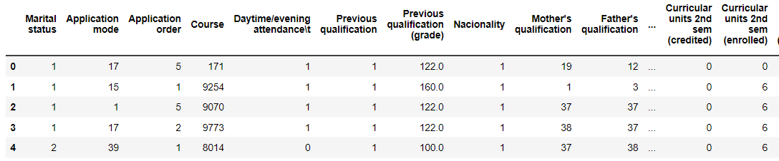

Data Cleanup
The original dataset consists of 36 variables and 4424 observations, including both numerical variables and several categorical variables. The categorical ‘Target’ variable is of particular importance as it is the dependent variable for our analysis consisting of three classes- Dropout, Enrolled, and Graduate.
As part of the Data cleaning process, the dataset was first examined for any missing values, and it was found that there were no missing values present. Next, we identified 12 unwanted columns in the dataset and decided to drop them since they had no significant role to play in the entire analysis such as application order, application mode, curricular units which are not evaluated, etc.
Furthermore, it was found that all the columns, including the categorical variables, were given in numerical format. Based on the given data dictionary, we found the numerical code associated with each unique class name of all the categorical variables and replaced them with the corresponding names to be able to make sense of the data and to be able to create effective visualizations. For Example, for Marital status, ‘0’ will make no sense to the audience as opposed to the name ‘Single’. This process is repeated for variables like Marital status, Previous qualification, Course, Mother’s and Father’s qualifications and Occupations, Nationality, and Gender.

Descriptive Analysis
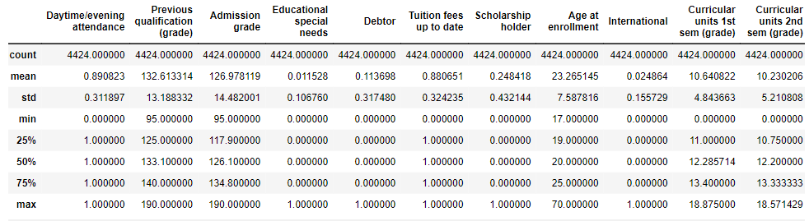
From the above description, we can conclude a few facts. The average previous qualification of the enrolled students is higher than the admission grade, which may imply a more than-required aptitude level of students during enrollment. There is no significant difference in grades obtained by students in the first and second semesters, which shows consistent performance in general. The median age of students at enrollment is 20 years. We consider median instead of age due to the presence of outliers wherein there are enrollments above 70 years of age as well. This may skew the mean value.
Further, only 1% of enrolled students require educational special needs, only 11% of students have debt on them and over 88% of students have paid their tuition fees on time. Only one-third of the students in this institution are scholarship holders.

Exploratory Data Analysis
To conduct a comprehensive analysis of the data, it is crucial to explore the variables in the dataset as well as any possible relationship between the dependent variable and other attributes. This will allow us to gain insights and enhance our understanding of the dataset.
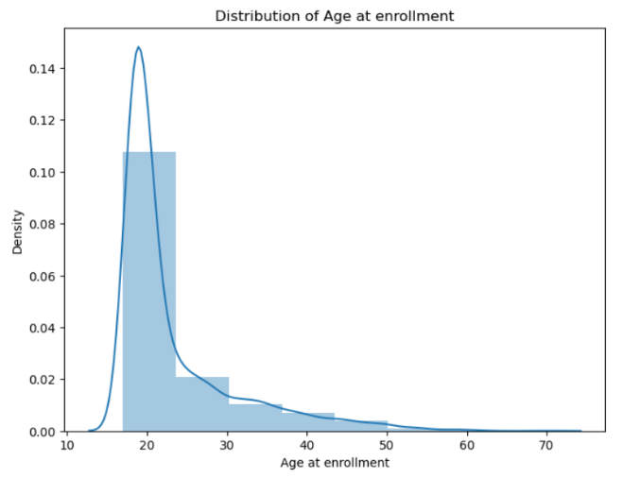
Figure 1: The Frequency distribution of age at enrollment:
The age of students at the time of enrollment ranges from around 15 years to 70 years. However, the maximum number of students enrolled in undergraduate degrees is roughly 18- 22 years old, which is the usual age group of undergraduates. The surprising revelation is that some enrolled students are 60 years and older as well.

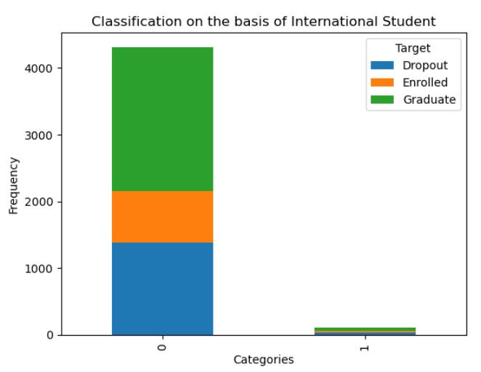
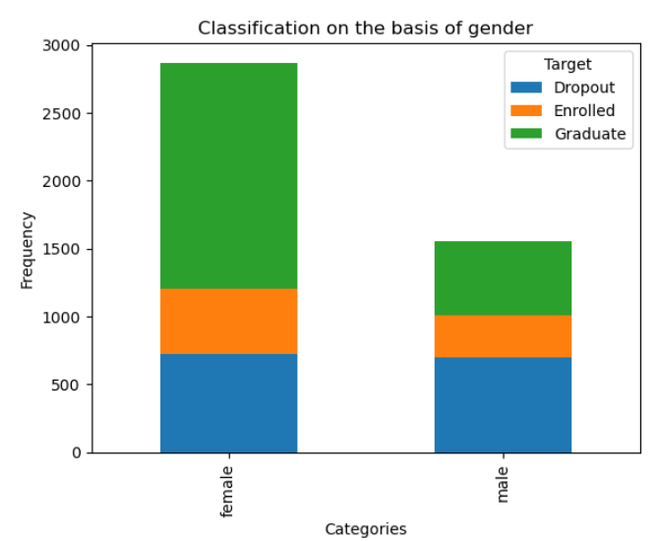
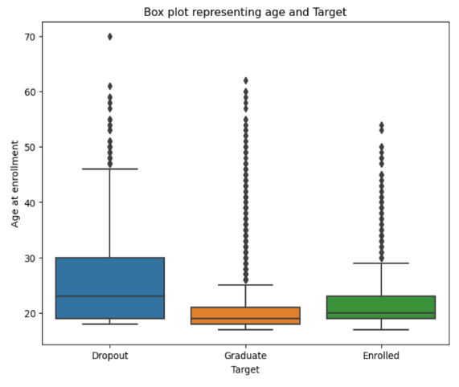
Figure 4: Stacked Bargraph for Target distribution under International student status
The bar graph shows that almost all the undergraduate students in this institution are domestic students and do not belong to international status. Among these, most of the students are graduates and a significant proportion of them are dropouts. This EDA reveals that since most of the enrollment data belongs to domestic students, this column does not hold any relevance to our analysis in the subsequent stages. Thus, we can drop this column altogether as part of the feature engineering process.

Figure 3: Stacked Bar graph for Target distribution under each gender
The above bar graph indicates a considerably higher number of female students involved with the institution compared to males. While gender does not seem to affect the dropout rate, the proportion of dropouts among males is greater than that among female students.
Figure 2: Age distribution of students under each Target class
To further investigate the age distribution of students on academic success, the boxplot reveals diverse ranges. It is observed that the age distribution of dropouts is the most varied, ranging between 18 to 45 years, with a median age of 23. Graduates show less variation, approximately 18 to 25 years, with a median age of 20. Despite numerous outliers, they hold important information and indicate that observations up to 60 years of age are typically normal, while anything beyond may be considered exceptional.

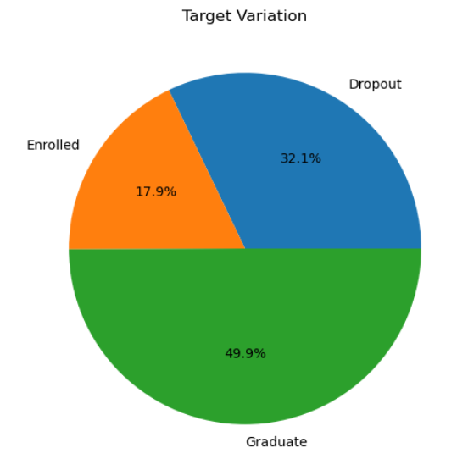
Figure 5: The Pie chart for Target distribution
The pie chart reveals that this data is highly skewed towards the students attaining ‘Graduate’ status at the end of the normal course of their program, such that the successful graduates account for almost 50% of the observations. This may create biases during predictive modeling, such that the ML models may be able to predict the more frequent class better than the other two classes.

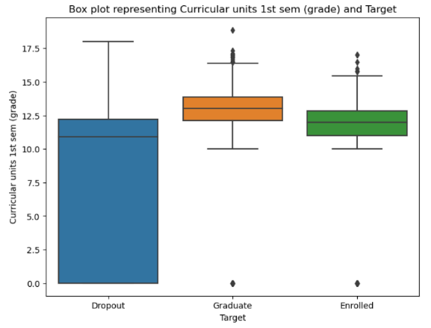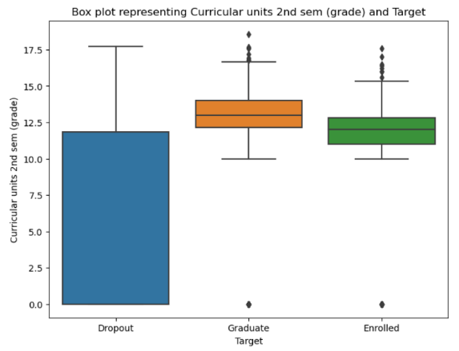
Figures 6 and 7: Grades distribution within each Target class
The group of boxplots in the left figure shows the distribution of grades in the first semester among dropouts, graduates, and currently enrolled students. The figure on the right show the same for grades obtained by students in the second semester. The figures above show that the median grades among dropout students are consistently lower than successfully graduated students and enrolled students. Moreover, the inconsistency revealed by larger variation in grades is also higher among the dropout category of students. The fact that median grades for graduate students are higher than that of students who are still enrolled shows the possibility of some struggle with the courses or the prevalence of more lenient grading in the final semesters of these degree programs. Most importantly, the above visualization establishes the fact that the grades obtained in the initial semesters may be indicative of the odds of academic success of a student associated with this institution.
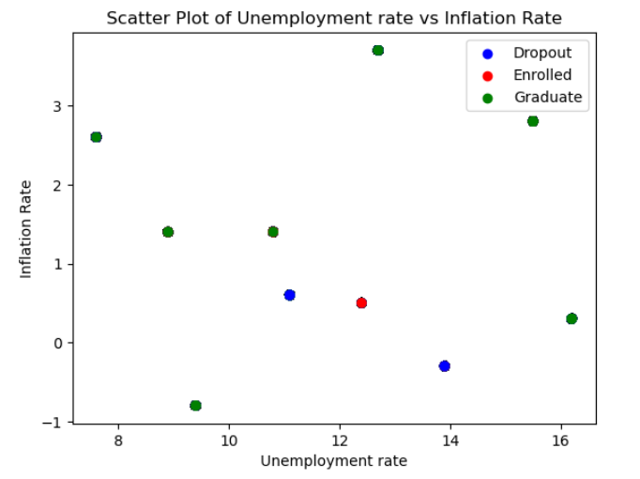
Figure 8: Scatter plot of Unemployment and inflation rate during the due course completion date
The inflation rate and unemployment rate considered in the above analysis belong to that time when the student is expected to graduate under the normal course of the program, irrespective of what happens. Based on this analysis, we can say that despite a few exceptions, the economic condition of the country seems normal since there is a significant negative correlation observed between inflation and unemployment. Under normal circumstances, any economy will observe a fall in the unemployment rate with an increase in inflation unless it is a case of ‘Stagflation’. Thus, the economic condition of the region may not impact the academic success of the students.
Figure 9: Stacked Bar graph for Target distribution among various Degree courses
The chart highlights the dominance of Nursing degree programs, followed by Management, social service, veterinary nursing, and Journalism and communication, with roughly equal proportions. Among these, Management stands out as the most concerning with the highest dropout rate, especially for both daytime and evening courses. Additional degrees with dropout rates surpassing graduation rates include Animation and Multimedia Design, Agronomy, Basic Education, Informatics Engineering, Equinculture, Oral hygiene, and Biofuel Production Technologies. These programs require immediate attention to improve student performance.
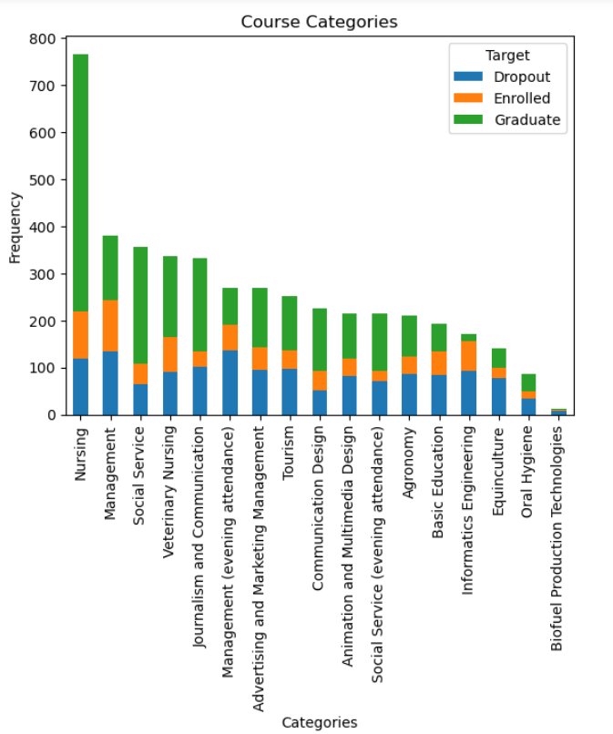
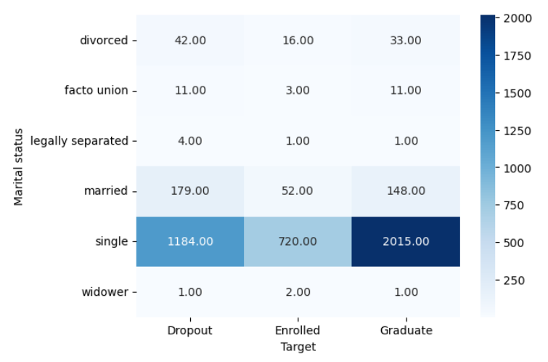
Figure 10: Heatmap of Marital Status vs Academic Success Status
The above heatmap shows that the maximum number of students enrolled in the institution were single at the time of enrollment, thus they are more likely to be the ones dropping out of degrees, graduating, or simply being enrolled. The more pertinent observation here is that there is very little difference between the number of students dropping out and the number of students graduating from the institution. Thus, this may be a cause of concern for the institution.

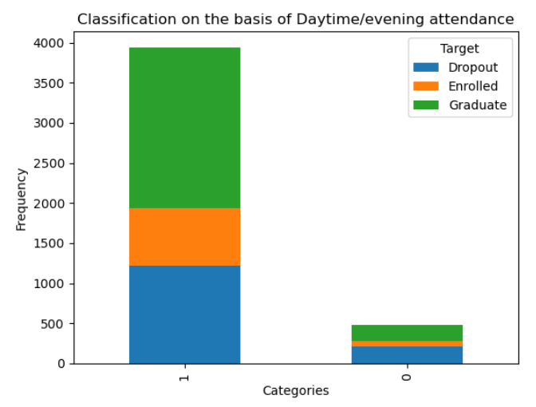
Figure 11: Stacked bar graph for Target distribution under Daytime (‘1’) and Evening (‘0’) Attendance
The above-stacked bar plot shows that more students are enrolled in the Daytime classes and there is no major difference between the distribution of academic success status between the daytime and the evening courses.

Feature Engineering
The above Exploratory Analysis in the form of visualizations has made important revelations and has successfully provided deep insights into the dataset. This has proven helpful in further refining the features of this dataset.
Feature engineering begins with categorizing Mother’s and Father’s occupations as well as their qualifications into a lesser number of categories. These columns are synchronized by categorizing all the qualification types under simpler groups such as Secondary education, Graduate, Master’s, Ph.D., and Others. This will not only simplify the analysis but also increase the interpretability of the results. Further, the records with the age of students higher than 70 years were dropped assuming they are outliers. The remaining age was binned and transformed into categories- child, adult, and senior- to reduce the number of unique values under this column. Further, since the focus of this project is on the prediction of dropout students, the enrolled and graduate class labels of the target variable were combined into one category- ‘non-dropouts’. Consequently, we have only 2 classes of target variables- ‘dropouts’ and ‘non-dropouts’.
To create Predictive tree models, the next step is to encode the categorical variables. Every categorical column has its own unique feature and needs to be engineered differently. So, we begin with the ‘Target’ column, wherein we simply label encode the two classes ‘1’ for ‘dropout’ and ‘0’ for ‘non-dropout’. For the ‘course category’, ‘Mother’s occupation’, and ‘Father’s occupation’ we use Target Encoding. The target encoding technique uses the mean value of the number of times a target class corresponds to that variable category and replaces that category name with the mean value. This method reduces the number of classes under the encoded columns and that is why these three columns have been chosen for target encoding. A one-hot encoding technique would generate too many features, whereas a label encoding might not be appropriate for cardinal categories. For the remaining categorical independent variables such as gender, marital status, age at enrollment, Father’s and Mother’s qualification, and previous qualification, we use one-hot encoding, since these features have not more than 2-3 categories.

Standardizing numerical data
Different features in the dataset may have different scales (ranges of values). Standardization rescales the features to have a mean of 0 and a standard deviation of 1. This process ensures that all features are on a similar scale, preventing one feature from dominating others during model training. Standardizing the data can lead to faster convergence during the optimization process of many machine learning algorithms. Gradient-based optimization methods, such as those used in logistic regression or neural networks, perform better when the features have similar scales. Thus, we standardize the trained data.

Predictive Modelling
To begin predictive modeling, we have successfully achieved a dataset with all the columns encoded appropriately according to their attributes. The first step before we begin to construct the tree-based classification models is to check if the data is imbalanced or not. The result shows that around 32% of the data belongs to the ‘dropout’ target class and almost 67% of the data belongs to the ‘non-dropout’ class of the target variable. Since almost 2/3 ^{rd} of the data belongs to one target class, we use the ‘stratify= y’ feature to ensure that the train-test splitting of the data is done in the same ratio with respect to the class distribution of y or target variable. Since logistic regressions and tree-based algorithms such as decision trees, random forests, and gradient boosting are not sensitive to the magnitude of variables, there will be no change in the splits due to such kind of a monotonic transformation. Therefore, we do not standardize columns before fitting these models.

Decision Tree Model
To train a Decision Tree classifier, visualize the tree structure, and make predictions on unseen data, we use the ‘sklearn’ package in Python and include the following hyperparameters:
- The ‘Gini’ impurity criterion to measure the quality of a split.
- The ‘max_depth’ of 3 for the Decision Tree, that is, the tree will have a maximum of 3 levels of decision nodes. This is done for mere interpretability of the tree and to avoid overfitting.
- ‘Random_state= 0’ is used to set the random seed for reproducibility.
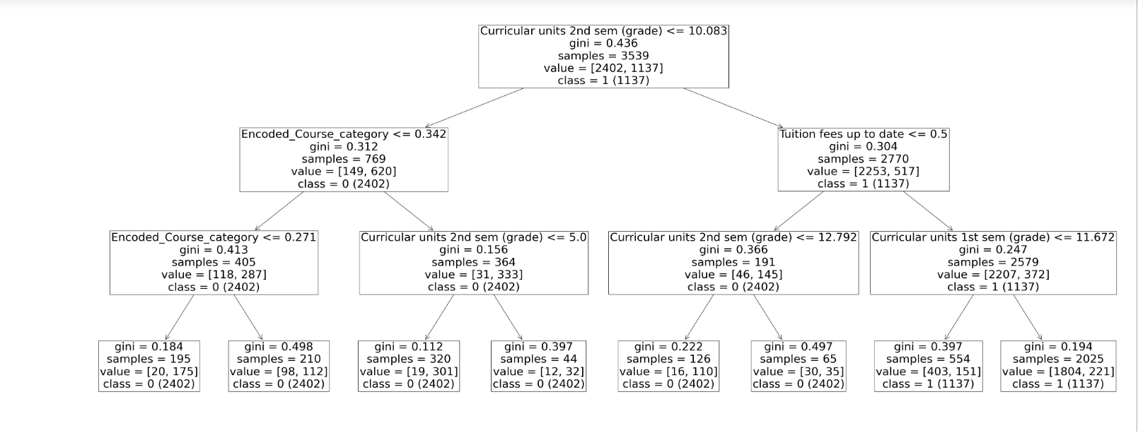
The above tree begins the classification decision route with the Curricular grades in the Second semester. At this stage, 3539 records are included wherein 1137 are likely to be dropouts if these grades are less than or equal to 0.083, with nearly 44% chances of misclassification. If the grades are more than 10, and the tuition fee is up to date, then out of a sample of 2579, 2207 are likely to be ‘non-dropouts’. Further, if the fee is up to date and the student scores more than 11.672 in the first semester curricular units, then out of 2025 samples, 1804 are likely to be ‘non-dropouts’. In summary, while predicting the majority class of ‘dropouts’, the likelihood of that instance is low.
Next, we move on to the feature importance graph to see which features are most crucial in predicting the likelihood of a student dropping out.
The feature importance graph below shows that the features that are most important in predicting the chances of a student dropping out are Curricular grade units in the second semester and the status of tuition fees being up to date in the accounts. As per the tree, the course of the decision branching explains that students without up-to-date tuition fees are more likely to be dropouts and lower grades in curricular grades are not indicating a ‘non-dropout’ prediction.

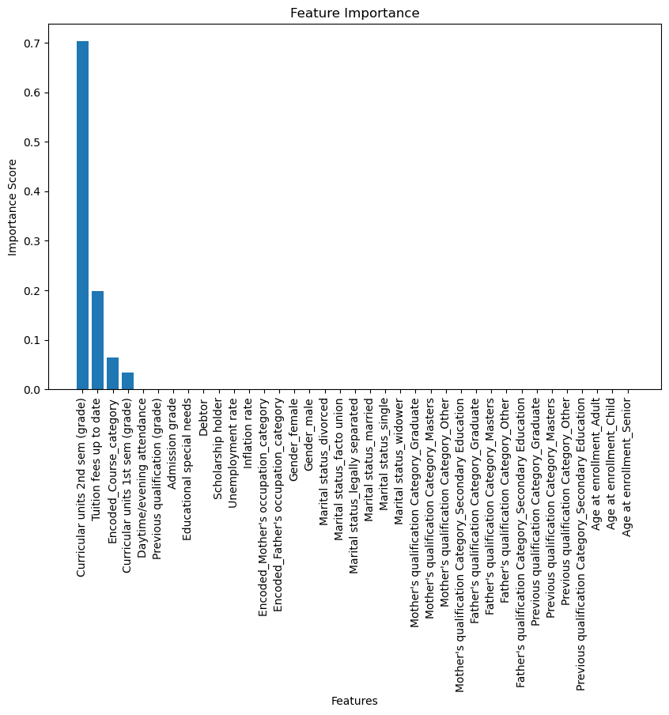
The confusion matrix below shows that the likelihood of correct predictions is far more than that of wrong predictions. The chances of predicting a dropout student as a non-dropout are far more than that of predicting a ‘non-dropout’ as a ‘dropout’. This is concerning as this may lead to ignorance on the part of the faculties in providing extra support to weaker students.
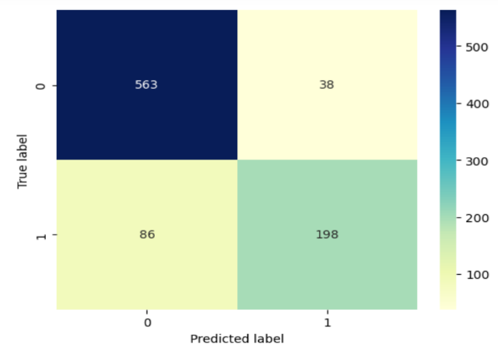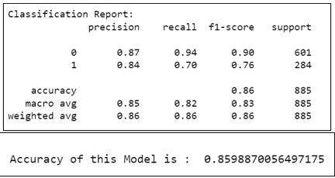
The performance report below shows a decent accuracy of nearly 86% but the accuracy alone is not a good metric since the data is highly unbalanced. This decision tree is better at predicting the ‘non-dropout’ class based on precision, recall and F1-score.

Random Forest Model
The random forest tree below shows that if the student is not a debtor, then out of 2235 samples, more are likely to be non-dropouts. The Father’s occupation and the status of tuition fee payment are the other two important features crucial for predicting the target class.
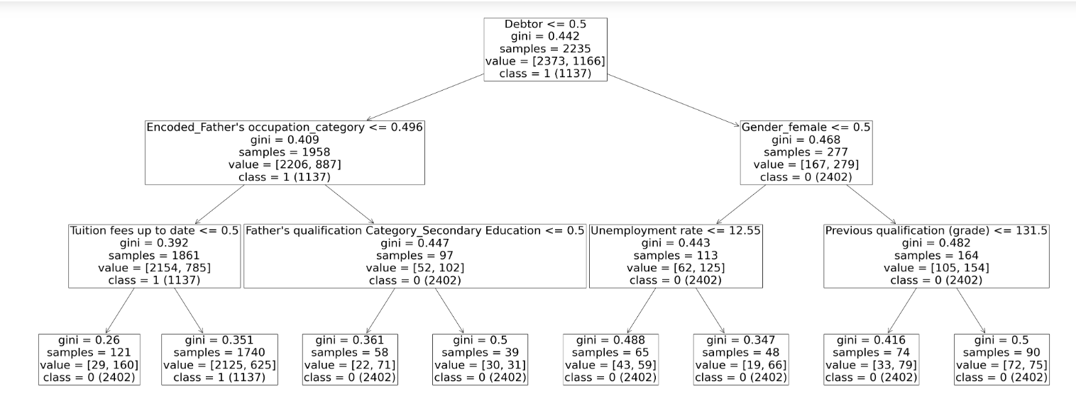
The below feature importance chart confirms the importance of features given by the decision tree. In addition, it suggests the importance of student attributes such as debt, scholarship, and course category.
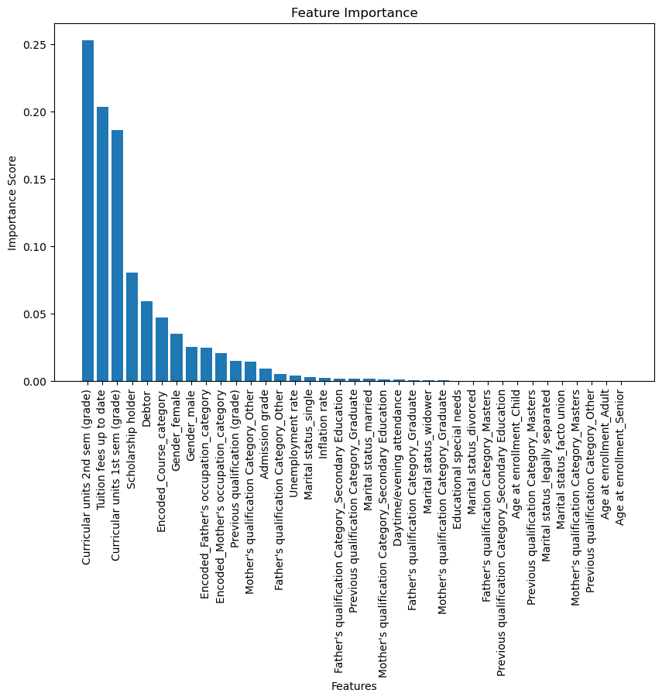
The confusion matrix shows that the probability of correct predictions is higher than the probability of errors. However, the fact that the wrong predictions with respect to a ‘drop-out’ student is higher and is a cause of concern.
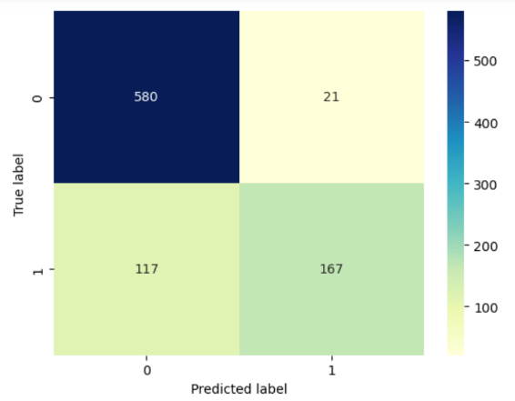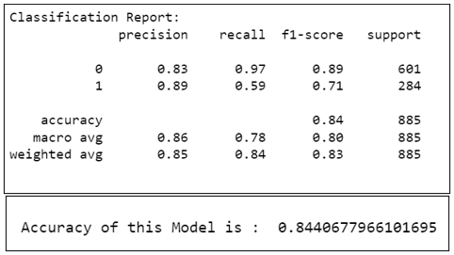
Since the data is imbalanced, an accuracy of 84% is not the most reliable metric and we move on to other metrics. Evidently, the precision, recall, and F1 score show that the model is better at predicting the class of ‘non-dropouts’. This is explainable because the data is highly skewed towards the ‘0’ class of non-dropout students. Overall, it is a better model for predicting the said class.

Gradient Boost Model
Gradient Boosting is an ensemble learning technique that builds multiple weak learner decision trees sequentially, where each new tree corrects the errors made by the previous ones. This gives us a strong predictive model that performs well and is less prone to overfitting.
The Gradient boost tree used Friedman’s MSE, that is Mean of squared errors, instead of Gini or entropy as the loss parameter. In the model below, the parent tree begins with the split condition that for all the 3539 sample records with curricular grade units in the second semester less than or equal to 10 are 100% likely to be non-dropouts. If their grades are in fact higher than 10 and their tuition fee is up to date then, there is only a 17% probability of the class being predicted as ‘dropout’. In summary, if the students are scoring above 10 in the first semester, above 11 in the second semester and their tuition fee is up to date then, the probability of the target class being predicted as ‘dropout’ is 97% among the sample size of 2025, with roughly 10% chance of error.
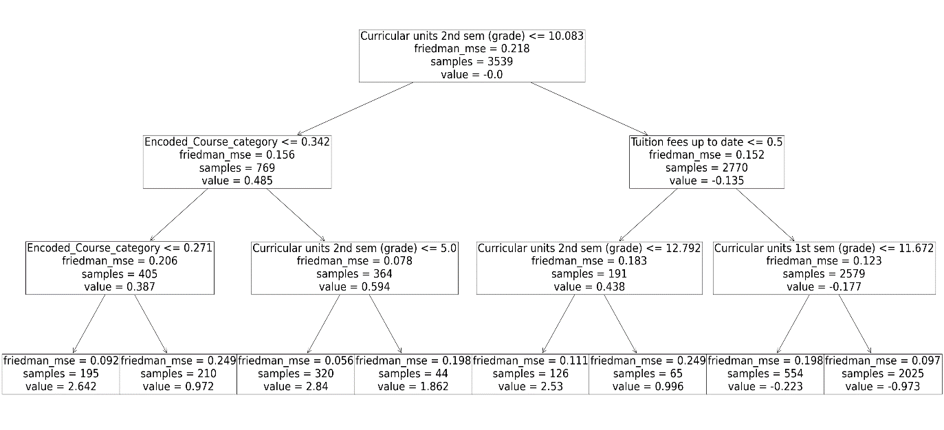
The feature importance graph below confirms the above findings by highlighting the importance of curricular grades in the first and second semester and the status of tuition fee payment as the important features in predicting the target class.
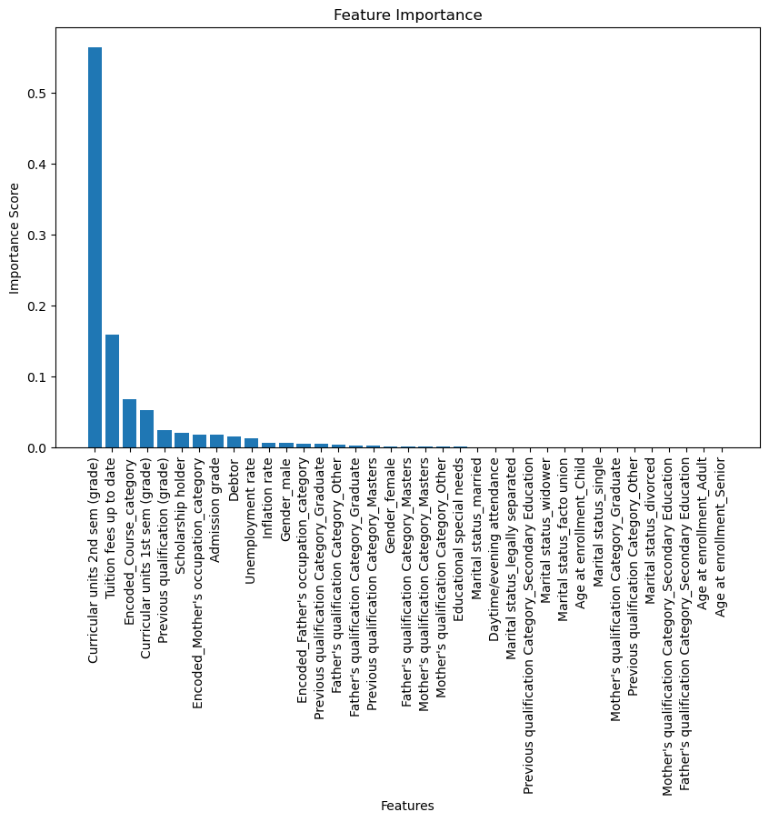
Compared to the instances of correct predictions, the confusion matrix shows far less chances of type 1 and type 2 errors. However, the higher chance of predicting the class of ‘dropouts’ wrong is a bit concerning.
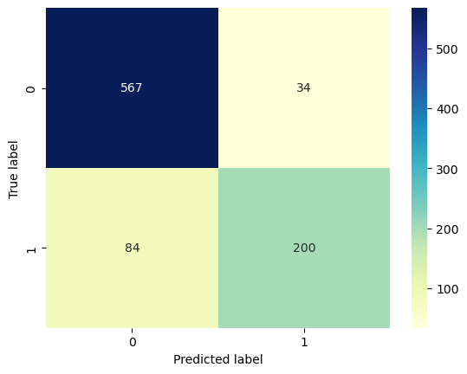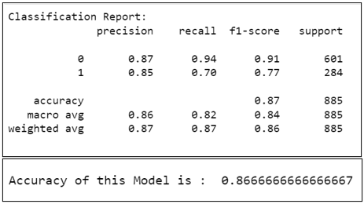
The gradient boost methodology has been successful in improving the accuracy of the random forest model to almost 87%. There is improvement in the predictability of both classes according to the precision, recall, and F1 Score. The model is better at predicting the ‘non-dropout’ class labeled as ‘0’ due to the skewness of data towards it.

XG Boost Model
The XGBoost model performs better than the Random Forest model when we have a class imbalance. The boosting algorithm iteratively learns, such that if a tree fails to predict the less frequent class, the proceeding tree will give more weightage to this sample. Intuitively, it makes the model less biased by giving more weightage to the less represented category of the target variable. On top of that, we undertake K-fold Cross-validation to estimate the performance of the XGBoost machine learning algorithm by training the data on k folds rather than on just a single train-test set split.
The below feature importance graph shows that the most important features are the status of the tuition fee payment, the curricular grade units for the second semester, and the father’s qualification.
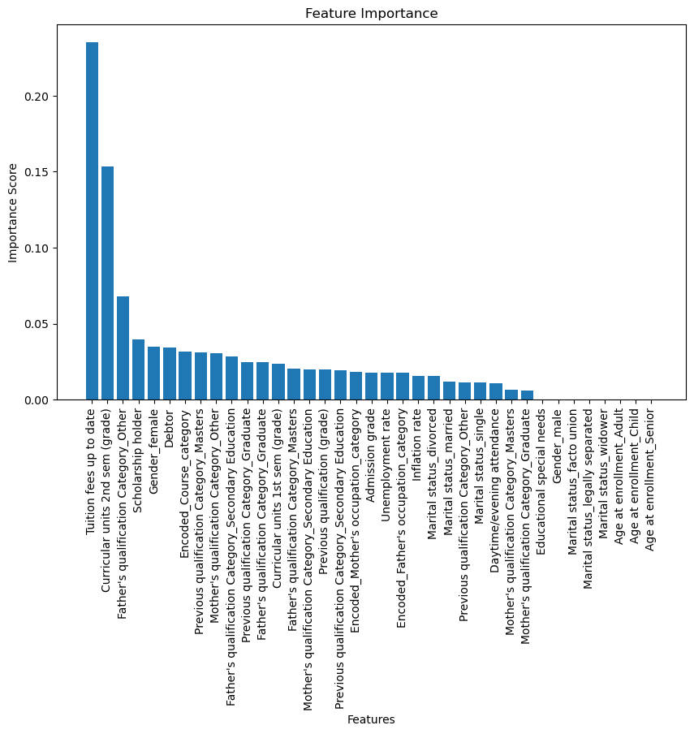
The confusion matrix below shows that the instances of correct predictions are much higher than that of wrong predictions. The concerning observation is the higher instances of wrong predictions for dropout students with respect to non-dropout students.
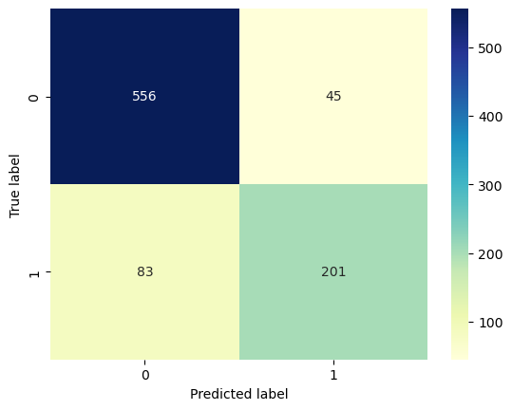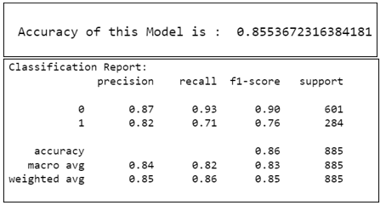
The accuracy of the model is 85.5%. Under XG boost model, since an unbalanced data issue is already addressed, accuracy is a reliable metric. However, precision, recall and F1 score shows a higher predictability of the ‘non-dropout’ class of target variable.

Hyper-parameter Tuning
Since the data is unbalanced and highly skewed towards the ‘non-dropout’ or ‘0’ class of the target variable, we choose the XGBoost model to get better results with a dataset such as this one. To increase its accuracy, we use the K-fold Cross-validation technique to test the data repeatedly k-1 times rather than on a single split, wherein each time the model iteratively learns from previous trees and improves itself.
Having done the above, we conduct Hyper-parameter tuning to further improve the accuracy of the model. The output below shows the best measures of the depth of the tree, the number of trees, and the rate of learning. Using these given parameters, we run the model again and get an improved accuracy of 87%.
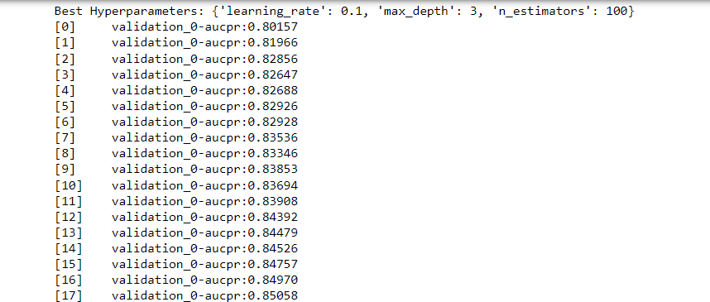
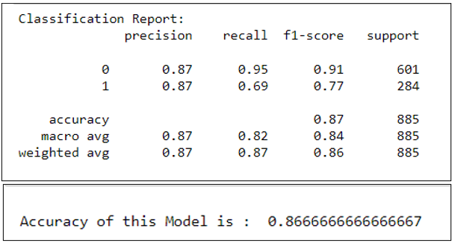

Logistic Regression Model
Feature Selection
After encoding the variables, the next step is to conduct feature selection before training the logistic regression model. This helps in controlling the extent of multicollinearity and avoid overfitting. We will use the Recursive Feature Elimination (RFE) technique to filter out features that are adding less value to the model performance.
RFE method works by starting with all features in the training dataset and iteratively removing features until the desired number of features remains or until the model's performance does not improve further. In this case, we have specified the top 10 features for selection.

Logistic Regression with Lasso Regularization
Lasso (Least Absolute Shrinkage and Selection Operator) regularization is a technique used in linear regression and other linear models to prevent overfitting and perform feature selection. The Lasso penalty tries to shrink coefficients towards zero, effectively eliminating the corresponding features from the model. Lasso is commonly used in situations where the dataset has many features. It is implemented using scikit-learn giving us the following log coefficients and their exponential values.
The exponential coefficient values show that for each one-unit increase in the corresponding variable, the odds of a student dropping out increase by a factor of that value. On the other hand, if the exponential value is less than 1, it means that for each one-unit increase in the independent variable, the odds of a student dropping out decrease by a factor of its coefficient’s exponential value.
Since we have already done the feature selection using the RFE technique, we can be sure that all the variables included in the model are significant with respect to their p-values. Now, we can use their coefficients to assess which variables are important contributors in deciding the odds of a student dropping out. The 3 most important features for which a unit increase in their value leads to an increase in the odds of a student dropping out are Course category, Mother’s occupation, previous qualification of graduates, and the Male gender of a student. However, an increase in the instances of paid tuition fees, scholarship holding status, and an increase in the age at enrollment causes a decrease in the chances of a student dropping out of university.
After we have trained the logistic regression model on the training dataset, we now move on to testing the model on the test set and then evaluating its performance with the help of key performance metrics and plots.
The confusion matrix on the left shows that the model makes majority correct predictions for the negative class of non-dropout students, however, it is concerning to see a high very number of wrong predictions made for dropout students. This implies that the model runs a high risk of causing the institution to neglect instances of students prone to dropping out of the course.

The accuracy of the model is roughly 79% but since the data is highly skewed towards the non-dropout class of the target variable, we will use other metrics like precision, recall, and F1 score to evaluate its performance.
Precision is the ratio of correctly predicted instances of a class to the total instances predicted for that class. It represents the model's ability to accurately predict cases for each class. High precision means that when the model predicts an instance as positive, it is likely to be correct. Recall is the proportion of correctly predicted instances of a class among all instances of that class in the dataset (i.e. if the class is positive, then all true positives + false negatives). Since we are more concerned about the right prediction of a student likely to drop out, we will focus on the recall and precision rate of the positive class ‘1’ assigned to ‘dropout’ students.
The precision rate states that 79% times the model makes a prediction, it predicts the odds of academic success of the student correctly. However, a low recall of 47% means that the model cannot identify most of the positive instances. A high recall is desirable when the cost of false negatives (misclassifying a positive sample as negative) is high in a case like this where the institution is at a high risk of ignoring a student on the verge of dropping out.
The ROC (Receiver Operating Characteristic) curve is used to evaluate the performance of a binary classification model graphically, at different classification thresholds. It plots the True Positive Rate (TPR) or the Recall against the False Positive Rate (FPR) for various threshold values. The closer the ROC curve is to the top-left corner, the better the model's performance. A curve that hugs the top-left corner indicates high TPR and low FPR, representing a well-performing model.
Area Under the Curve (AUC) represents the area under the ROC curve. The AUC ranges from 0 to 1, where 0.5 indicates a random classifier, and 1 represents a perfect classifier. A higher AUC indicates better model performance. The AUC of 0.81 is closer to 1 than farther away along with a higher ROC curve. A model with an ROC curve close to the top-left corner and a high AUC is considered to have good discriminatory power and is more accurate in classifying positive and negative instances.

An ROC curve provides an overly optimistic picture of the performance, compared to a Precision-Recall (PR) curve, when it comes to imbalanced classification. Also, when class distribution changes, the ROC curve doesn’t change while a PR curve reflects the change.
The area under the PR ROC curve is higher than 0.5, at 0.71. Thus, the model can be considered to have good discriminatory power and good accurate in classifying positive instances while maintaining high precision, as observed in the curve on the left.

Logistic Regression with Ridge Regularization
The same procedure is conducted to create a logistic regression model, however, in this section, we use Ridge regularization. Ridge regularization, also known as L2 regularization, is a regularization technique used in logistic regression and other linear models to prevent overfitting and improve model generalization. It adds a penalty term to the cost function based on the squared magnitudes of the model's coefficients.
The penalty='l2' specifies the ridge type of regularization being used in the logistic regression model. L2 regularization adds a penalty term based on the squared magnitudes of the coefficients to the cost function, helping prevent overfitting and improve generalization. The solver= 'liblinear' specifies the algorithm used to optimize the logistic regression model. For L2 regularization with logistic regression, 'liblinear' is a good choice for small and medium-sized datasets in scikit-learn.
In standard logistic regression without regularization, the cost function is based on the negative log-likelihood of the data, and the model aims to minimize it. On running L2 regularization to create Logistic Regression Model on standardized dataset with top 10 selected features, we understand that among the top 10 significant features selected by RFE technique, the major features whose per unit increase causes an increase in the odds of a student dropping out are course category, mother’s occupation, previous qualification of graduates and male gender. The features that lead to a decrease in the odds of a student dropping out with respect to a per unit increase in their value are paid-up tuition fee, scholarship, and age at enrollment.
The confusion matrix below shows that the model makes majority correct predictions for the negative class of non-dropout students, however, it is concerning to see a high very number of wrong predictions made for dropout students. This implies that the model runs a high risk of causing the institution to neglect instances of students prone to dropping out of the course.
The confusion matrix on the left shows that the model makes majority correct predictions for the negative class of non-dropout students, however, it is concerning to see a high very number of wrong predictions made for dropout students. This implies that the model runs a high risk of causing the institution to neglect instances of students prone to dropping out of the course.
The accuracy of the model is roughly 79% but since the data is highly skewed towards the non-dropout class of the target variable, we will use other metrics like precision, recall, and F1 score to evaluate its performance.
The precision value for a positive class of ‘drop-out’ students states that 79% times the model makes a prediction, it predicts the odds of academic success of the student correctly. However, a low recall of 47% means that the model cannot identify most of the positive instances. A high recall is desirable when the cost of false negatives (misclassifying a positive sample as negative) is high in a case like this where the institution is at a high risk of ignoring a student on the verge of dropping out.
The F1 score penalizes models having a high precision but a low recall or vice versa. It gives the Harmonic Mean of the two metrics to give equal importance to both and provides a more balanced evaluation of the model's performance. The F1 score for drop-out class is as low as 59%.

The Area Under the Curve (AUC) represents the area under the ROC curve. The AUC ranges from 0 to 1, where 0.5 indicates a random classifier, and 1 represents a perfect classifier. A higher AUC indicates better model performance. The AUC of 0.81 is closer to 1 than farther away, along with a higher ROC curve. A model with an ROC curve close to the top-left corner and a high AUC is considered to have good discriminatory power and is more accurate in classifying positive and negative instances.
An ROC curve provides an overly optimistic picture of the performance, compared to a Precision-Recall (PR) curve, when it comes to imbalanced classification. Also, when class distribution changes, ROC curve doesn’t change while a PR curve reflects change. An area under the ROC curve is higher than 0.5, at 0.72. Thus, the model can be considered to have good discriminatory power and good accurate in classifying positive instances while maintaining high precision, as observed in the curve on the left.
The Area Under the Curve (AUC) represents the area under the ROC curve. The AUC ranges from 0 to 1, where 0.5 indicates a random classifier, and 1 represents a perfect classifier. A higher AUC indicates better model performance. The AUC of 0.81 is closer to 1 than farther away, along with a higher ROC curve. A model with a ROC curve close to the top-left corner and a high AUC is considered to have good discriminatory power and is more accurate in classifying positive and negative instances.
A ROC curve provides an overly optimistic picture of the performance, compared to a Precision-Recall (PR) curve, when it comes to imbalanced classification. Also, when class distribution changes, the ROC curve doesn’t change while a PR curve reflects the change. An area under the ROC curve is higher than 0.5, at 0.72. Thus, the model can be considered to have good discriminatory power and good accuracy in classifying positive instances while maintaining high precision, as observed in the curve on the left.
In Summary, both Ridge and Lasso Regularization methods give exactly the same accuracy, precision, recall, and F1 score values, along with the same features of importance and higher predictability for the negative class compared to the positive class. The accuracy level for the Ridge model is negligibly higher than that achieved with Lasso. Since the PR ROC curve is more appropriate to evaluate model performance in case of imbalanced data, we observe that the AUC under the PR curve for Ridge logistic regression model is slightly higher at 0.72 compared to 0.71 in the case of Lasso, therefore we may prefer the Ridge method.

Support Vector Machine Model
Support Vector Machine (SVM) models are machine learning models used on medium-sized data for both classification and regression tasks. We built an SVC (Support Vector Classification) model which is a specific variant of SVM used for classification problems. SVC is often used for binary classification problems where the goal is to predict one of two possible classes.
We will create an SVM model with a linear kernel. The 'linear' kernel is suitable for linearly separable data, and it works well for binary classification tasks. We also enable ‘probability=True’ to enable probability estimates for each class, which is useful for calculating metrics like the ROC curve or precision-recall curve. We get a feature importance graph showing us the most important features for classifying the target variable ‘Target’ into classes ‘dropout’ and ‘non-dropout’. The features shown are as follows:
The above plot shows that the most important features are Tuition fee payment status, previous qualification of graduates and legally separated single students. However, an up-to-date tuition fee payment implies that the model is more likely to predict that the student is not a drop out. An increase in mother’s qualification or increase in legally separated marital status implies that the model is more likely to predict that the student will dropout.

The ROC (Receiver Operating Characteristic) curve plotting the True Positive Rate (TPR) or the Recall against the False Positive Rate (FPR) for various threshold values is shown below:
The confusion matrix on the left shows that the model makes majority correct predictions for the negative class of non-dropout students, however, it is concerning to see a high very number of wrong predictions made for dropout students. This implies that the model runs a high risk of causing the institution to neglect instances of students prone to dropping out of the course.
A higher AUC indicates better model performance that is why the AUC at 0.79 being closer to 1 than farther away, along with a higher ROC curve is a good indicator for the model. A model with an ROC curve close to the top-left corner and a high AUC is considered to have good discriminatory power and is more accurate in classifying positive and negative instances.
The accuracy of the model is almost 78% but since the dataset is imbalanced, we will consider more precise performance metrics such as precision, recall and F1 score.
The table below shows that the model performs very well with 80% precision in correctly predicting the positive class of dropout students among all the predictions made for this class. As per the recall value we can say that the model is weak at identifying positive classes among all the positive classes present in the dataset. Since, the instances of false negatives is high as observed in the confusion matrix, it is necessary to have a higher recall value.

Hyper-tuned SVM model
GridSearchCV is a method for performing hyperparameter tuning using cross-validation. We input a a list of dictionaries with only one dictionary containing the 'C' parameter with values [0.001, 0.01, 1, 10] where the 'C' parameter is the regularization parameter in the SVM model. Thus, we tune the Support Vector Classifier (SVC) with a linear kernel to cv=10 such that 10-fold cross-validation is undertaken (to save computational time and power due to technological constraints), and the hyperparameters are optimized based on ‘accuracy’ level. Based on this, we received 0.01 value of ‘C’ as the best parameter, shown as follows:
Thus, by using GridSearchCV, we can automatically search through different hyperparameter combinations and find the best set of hyperparameters that optimize the model performance. It saves time and effort in manually tuning hyperparameters. Finally, the above code gives the following performance metrics of the hyper-tuned model after testing it on the test set:
The confusion matrix on the left shows that the model makes majority correct predictions for the negative class of non-dropout students, however, it is concerning to see a high very number of wrong predictions made for dropout students. This implies that the model runs a high risk of causing the institution to neglect instances of students prone to dropping out of the course.
The accuracy of the model is still the same as before with almost 78% accuracy rate. To evaluate the imbalanced dataset on more specific performance metrics, we move on to the precision of predicting the positive class of dropout students which is high at 80% correct predictions made among all the predictions made for positive class. This value is same as that of the model before hyper-tuning. Moreover, since the instances of false negatives is high, a high recall value is crucial for model performance which again is as low as 40%.

Area Under the Curve (AUC) represents the area under the ROC curve. The AUC ranges from 0 to 1, where 0.5 indicates a random classifier, and 1 represents a perfect classifier. A higher AUC indicates better model performance. The AUC of 0.81 is closer to 1 than farther away along with a higher ROC curve. A model with an ROC curve close to the top-left corner and a high AUC is considered to have good discriminatory power and is more accurate in classifying positive and negative instances.

Model Comparison

Model Type | Accuracy | Predicted class | Precision | Recall | F1 score
Decision Tree Model | 86 | 1 | 84 | 70 | 76
Random Forest Model | 84 | 1 | 89 | 59 | 71
Gradient Boost Model | 87 | 1 | 85 | 70 | 76
XG Boost | 85.5 | 1 | 82 | 71 | 76
XGBoost (Hyper-tuned) | 87 | 1 | 87 | 69 | 77
Logistic Regression (Lasso) | 78.87 | 1 | 79 | 47 | 59
Logistic Regression (Ridge) | 78.98 | 1 | 79 | 47 | 59
SVM Model  0.79 | 77.62 | 1 | 80 | 40 | 54
Hyper-tuned SVM Model  0.78 | 77.62 | 1 | 80 | 40 | 54

The Decision Tree Model shows an Accuracy of nearly 86%. It is a simple and highly interpretable model, providing insights into important features. However, it is prone to overfitting. With the Random Forest Model, the accuracy decreases to 84% but it is sure to reduce overfitting by averaging multiple trees and the reduction in accuracy may not be a cause of concern here. The Gradient Boosting model builds trees sequentially, each subsequent tree correcting the errors made by the previous ones in terms of misclassification of samples, leading to a more generalized model. Since it works on misclassification errors, it is bound to make a model perform better on imbalanced data. As a result, the Gradient Boost Model shows an accuracy of almost 87%. However, this makes it more sensitive to hyperparameters and may require more tuning. Thus, XG Boost Model is constructed along with the k-fold cross-validation technique to further improve on the issue of overfitting. The accuracy reduces to 85.5% and may require more tuning. The hyper-tuned XGBoost model is finally the most reliable model with an accuracy of 87%.
Overall, all four models perform relatively well with accuracies ranging from 84% to almost 87%. Since the data is imbalanced, it's essential to focus on metrics beyond accuracy, such as precision, recall, and F1-score. These metrics indicate that all models are better at predicting the 'non-dropout' class ('0') due to the skewed distribution of data towards that class.
The Gradient Boost and Hyper-tuned cross-validated XG Boost models tend to have slightly higher performance compared to the Decision Tree and Random Forest models, especially in terms of accuracy and precision.
The area Under the Curve (AUC) represents the area under the ROC curve. The AUC ranges from 0 to 1, where 0.5 indicates a random classifier, and 1 represents a perfect classifier. A higher AUC indicates better model performance. The AUC of 0.81 is closer to 1 than farther away along with a higher ROC curve. A model with a ROC curve close to the top-left corner and a high AUC is considered to have good discriminatory power and is more accurate in classifying positive and negative instances.
The above table shows that out of the two models Logistic and SVM models, we will use the Ridge regularized logistic model to compare with the hyper-tuned SVM model. Although the accuracy of the SVM model is slightly lower than that of the logistic regression model, along with a fall in the area under the ROC curve, the hyper-tuned SVM model shows higher precision in predicting the positive class of ‘dropout students’ which is the target and the goal of this project. Moreover, the fall in accuracy in the SVM model is justified because it optimizes the model by addressing the problem of overfitting. However, since the instances of false negatives are very high, we would like to choose a model with a higher recall value for the positive class. Thus, we choose Ridge regularized Logistic regression model for analysis.

Conclusion
The goal of this project is to predict the risk of dropout and failure to help the institution provide targeted support to the enrolled students. This report has been the stepping stone in that direction by introducing the dataset, identifying the use case, cleansing it, and finally conducting a comprehensive Exploratory Data Analysis.
The analysis so far reveals that 50% of the observations belong to students who have graduated successfully, thus, the data is skewed towards one class of the target variable. Most students enrolled in the institution belong to 18-22 years of age at the time of enrollment. However, there are too many instances of adults enrolling in undergraduate degrees beyond that and up to 70 years of age. Thus, age may be an important factor in curating targeted measures to provide academic support.
The marital status and international status of the student may be excluded from the dataset since almost the entire set of observations belong to single and domestic students. Additionally, the economic condition of the region at the due time of graduation for all the students is normal. Since the unemployment rate and inflation rate follow a normal correlation, we can assume that academic success did not get affected by the prevailing economic condition.
Further, the institution has a higher enrollment of female students and a higher dropout proportion among male students. Moreover, the grades obtained in the first and second semesters are highly indicative of the academic success of the students by the end of their course. Thus, academic support from the very beginning is necessary to ensure a reduction in failure or dropout rate and there is a need to examine the cause of higher failure among male students.
In this project, we focused on predicting student dropouts using tree-based classification models. We performed extensive feature engineering, including categorizing occupations and qualifications, handling age outliers, and encoding categorical variables. We then built and compared four models: Decision Tree, Random Forest, Gradient Boost, and XG Boost.
Based on our analysis, the hyper-tuned XG Boost model emerged as the most reliable and accurate model, achieving an accuracy of 87%. This model effectively addressed the class imbalance issue and demonstrated improved precision, recall, and F1-score for both dropout and non-dropout classes. The importance of features such as curricular grade units, tuition fee status, and father's qualification was highlighted, providing valuable insights into dropout prediction.
The above models show that students scoring higher than 10 in the first and second semester curricular grades along with an up-to-date tuition fee payment are more likely to be dropouts. This sounds like an anomaly, but it is worth noting that the models suggest that tuition fee payment and good academic scores are not the factors inducing students to drop their courses. This implies that there may be other causes than the most obvious ones.
The other two factors highlighted by the analysis are the father’s qualifications and course category. These two factors can be further analyzed to see how they influence the dropout rates in the institute and which courses are not being well-received by the students. There may be certain courses that cost more to the students while giving less returns in terms of job prospects. And this may be pushing the students to drop out before finishing the degree. Also, it can be further investigated how a father’s qualification influences student success in academics.
In one of the trees, it was also highlighted that if the student is a male debtor, the chances of them dropping out were higher within that sample. This can be noted by keeping a closer track of students showing these attributes.
In conclusion, the application of machine learning models, particularly the hyper-tuned XG Boost model, can significantly contribute to identifying and addressing student dropout rates. By implementing early intervention strategies and leveraging the insights provided by the model, educational institutions can take proactive steps to support at-risk students and promote academic success for all.
In this report, we explored two supervised learning models, Logistic Regression and Support Vector Machine (SVM), to predict the likelihood of students dropping out of university based on various independent variables. On comparing the models, we selected the Ridge regularized Logistic Regression model due to its slightly but significantly better performance in terms of Recall value for positive class which is the focus of this project . However, we acknowledge the challenge of dealing with imbalanced data and the need to balance precision and recall for dropout prediction.
For the Logistic Regression model, we found that Course Category, Mother's Occupation, previous qualification of graduates and Male Gender were the most important features that increased the odds of a student dropping out. On the other hand, Paid Tuition Fee, Scholarship, and Age at Enrollment were features that decreased the odds of dropout.
Based on the above features, targeted Intervention Programs for At-Risk Students can be implemented using academic counseling, mentorship, or additional support to help students overcome challenges specific to their backgrounds or course categories.
Since Up-to-date Tuition Fee and Scholarship holdings were found to decrease the odds of dropout, the university can consider offering more financial aid options, scholarships, or tuition fee assistance programs. Reducing financial barriers can significantly impact students' ability to continue their education without financial strain. For students who are legally separated or have family responsibilities, universities can provide additional support services tailored to their unique needs.
Since Male Gender was identified as a factor increasing the odds of dropout, universities can develop gender-specific support programs addressing challenges faced by male students and create a more inclusive and supportive environment to encourage their academic success. Further investigation can be undertaken to assess how Mother’s occupation and Course category is affecting student’s academic success so that targeted interventions can be made.
Overall, the models provided valuable insights into the factors influencing student dropout and can be used to identify at-risk students early, allowing universities to intervene and provide necessary support to improve student retention rates. Further research and improvements in data collection may be needed to address the imbalance issue and enhance model performance in accurately identifying potential dropout students.

References
Dugar, D. (2023, May 13). Feature engineering in Python - towards data science. Medium. https://towardsdatascience.com/feature-engineering-in-python-part-i-the-most-powerful-way-of-dealing-with-data-8e2447e7c69e
GeeksforGeeks. (2022). Data Visualization with Python. GeeksforGeeks. https://www.geeksforgeeks.org/data-visualization-with-python/
Intro to Feature Engineering for Machine Learning with Python. (n.d.). https://www.learndatasci.com/tutorials/intro-feature-engineering-machine-learning-python/
Plotly. (n.d.). https://plotly.com/python/
Python, R. (2023). Pythonic Data Cleaning With pandas and NumPy. realpython.com. https://realpython.com/python-data-cleaning-numpy-pandas/
UCI Machine Learning Repository. (n.d.). https://archive.ics.uci.edu/dataset/697/predict+students+dropout+and+academic+success
GeeksforGeeks. (2021). Histograms and Density Plots in Python. GeeksforGeeks. https://www.geeksforgeeks.org/histograms-and-density-plots-in-python/
GeeksforGeeks. (2022a). Box Plot in Python using matplotlib. GeeksforGeeks. https://www.geeksforgeeks.org/box-plot-in-python-using-matplotlib/
GeeksforGeeks. (2022b). Plotting Correlation Matrix using Python. GeeksforGeeks. https://www.geeksforgeeks.org/plotting-correlation-matrix-using-python/
Maklin, C. (2022, May 9). K Nearest Neighbor Algorithm In Python - Towards Data Science. Medium. https://towardsdatascience.com/k-nearest-neighbor-python-2fccc47d2a55
Specifying colors — Matplotlib 3.7.1 documentation. (n.d.). https://matplotlib.org/stable/tutorials/colors/colors.html#cn-color-selection
Wasnik, A. (2020, October 27). How to Plot K-Means Clusters with Python? - AskPython. AskPython. https://www.askpython.com/python/examples/plot-k-means-clusters-python
1.10. Decision Trees. (n.d.). Scikit-learn. https://scikit-learn.org/stable/modules/tree.html
Brownlee, J. (2021a). How to Develop Your First XGBoost Model in Python. MachineLearningMastery.com. https://machinelearningmastery.com/develop-first-xgboost-model-python-scikit-learn/
Brownlee, J. (2021b). How to develop a gradient boosting machine ensemble in Python. MachineLearningMastery.com. https://machinelearningmastery.com/gradient-boosting-machine-ensemble-in-python/
GeeksforGeeks. (2023). Random forest regression in Python. GeeksforGeeks. https://www.geeksforgeeks.org/random-forest-regression-in-python/
Sarr, M. (2021). Hyperparameter Tuning with Grid Search in Python. Malick Sarr. https://www.malicksarr.com/hyperparameter-tuning-with-grid-search-in-python/#:~:text=Hyperparameter%20Tuning%20with%20Grid%20Search%20in%20Python%201,3%203.%20Create%2C%20initialize%20and%20test%20your%20model
Sklearn.tree.plot_tree. (n.d.). Scikit-learn. https://scikit-learn.org/stable/modules/generated/sklearn.tree.plot_tree.html
Zach. (2022). K-Fold Cross validation in Python (Step-by-Step). Statology. https://www.statology.org/k-fold-cross-validation-in-python/

